https://conceptdraw.com/a2246c3/preview:
MS Windows Vista user interface - Vector stencils library
The vector stencils library "MS Windows Vista user interface" contains 76 MS Windows Vista design elements. Use it for designing Microsoft ribbon graphic user interface (GUI) of software for computers with MS Windows Vista OS in the ConceptDraw PRO diagramming and vector drawing software extended with the Graphic User Interface solution from the Software Development area of ConceptDraw Solution Park.

Window
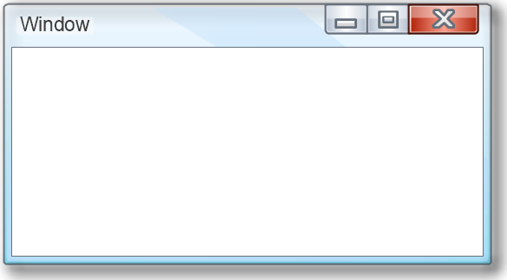

Dialog Window
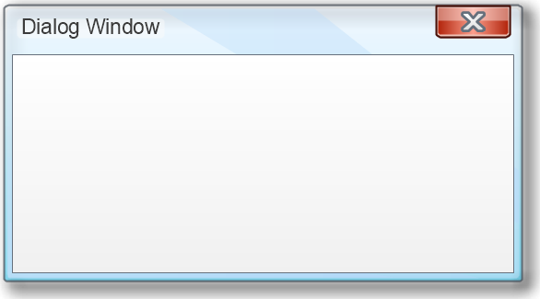

Empty Window
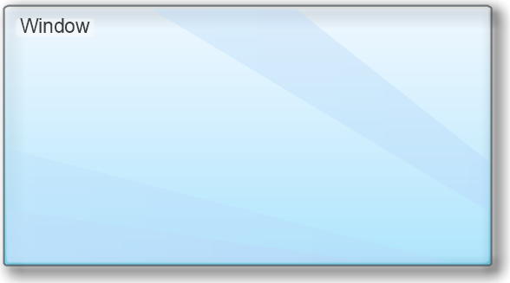

Field


Horizontal Scrollbar

Vertical Scrollbar

Window Buttons


Window Buttons


Window Button 1


Window Button 2


Window Button 3


Window Button 4


Navigation


Menu Bar
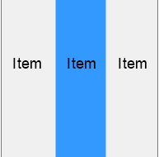

Gradient Menu Bar
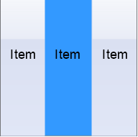

Drop-down Menu
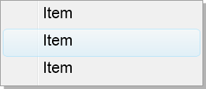

Button


Toolbar Pannel


Tool Button
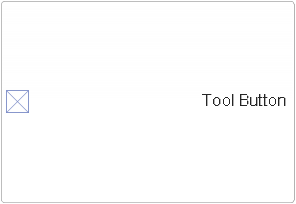

Primary Toolbar


Toolbar 1


Toolbar 2


Customizable Tollbar


Tab View
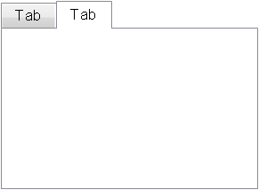

List View

Text Field
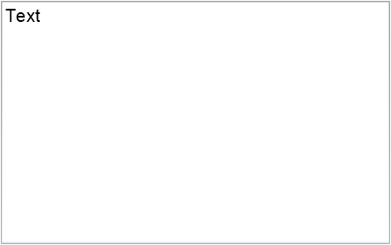

Vertical Separator

Horizontal Separator

Group Box
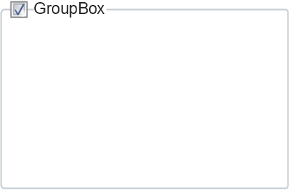

Text Label

Link

Line Edit


Search


Search with Button


Spin Box


Combo-box
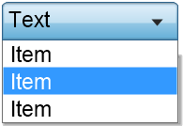

Editable Combo-box
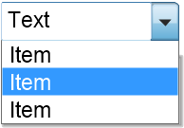

Editable List Box
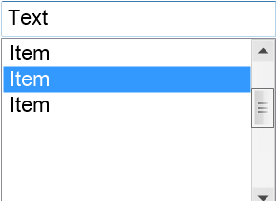

List Box
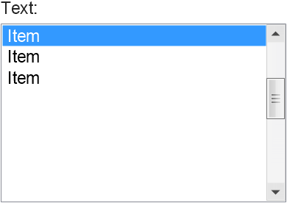

Single-selection List


Multiple-selection List


Check Box

Radio Button

Check box group
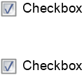

Radio Buttons Group
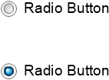

Progress Bar

Modal Progress Bar

Vertical Slider with Ticks


Horizontal Slider with Ticks


Dial


Catalogue Tree
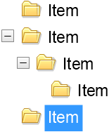

Tree View 1


Tree View 2


Vertical Spacer


Horizontal Spacer


Chevron 1


Arrow 1


Arrow 2

Plus/Minus Control

Rotating Triangle

Chevron 3

Chevron 2


Normal Select Cursor

Link Select Cursor


Text Select Cursor

Working in Background Pointer


Busy Pointer


Unavailable Cursor


Precision Select Cursor


Error Icon


Warning Icon


Information Icon


Question Mark Icon


Balloon


Tooltip/Infotip


Calendar
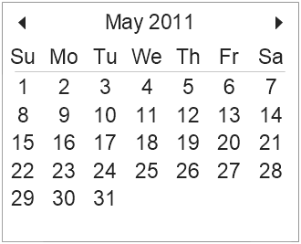

(при нужда) вж. и: https://msdn.microsoft.com/en-us/library/windows/desktop/dn742466(v=vs.85).aspx

